**Description of Practical Assignment “Idea Box”**

**Team of Developers**

There is one student participating in the development of the system:

- Andris Lapiņš al18011 (design, business logic development, user interface design, programming of controllers and models)

**Development Environment**

It is planned to develop the system in PHP 7.1 environment using Laravel 5.6 library. It is planned to use MySQL database for data storage.

**Main Functionality**

Within the framework of the practical assignment, it is planned to develop a website designed for note taking, idea sharing and archiving.

It will be possible to post ideas (title and body) and photos as attachments in the system as an user. Visitors will be able to see the ideas of the users. Only users will be able to add a comment to other user posts. Users will be able to edit their posts (with bullet-points, bold text etc.) and delete them. Visitors and users will be able to use a search-bar to search posts by title. Every user will be able to add a discussion (idea with or without comments) to his ‘’favourite’’ section.

**Data Registry**

The most significant concepts in the system: idea, comment, discussion, user.

The system consists of discussions, the author is one of the users. Each discussion consists of text and/or a photo. Ideas are tied to a particular user. Comments belong to other users but the author of the idea can delete other user comments.

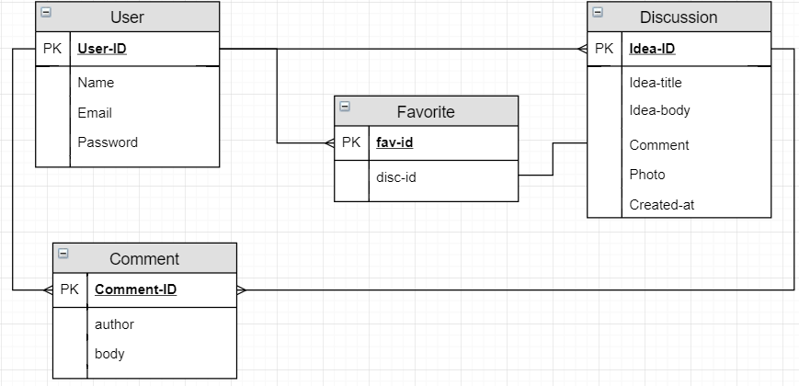

[Created with draw.io desktop application]

**MVC**

The system will be implemented following an MVC paradigm. The system will be distributed into the following components:

Models:

- User,

- Discussion,

- Comment,

- Idea,

- Favourites;

Views:

- list of discussions with a search box,

- view of a dashboard of personal posts

- view with idea’s title, its body(+photo) and a list of comments

- new idea post creation view,

- view for discussion (comment deleting and idea edit) editing,

- view for adding a comment to an idea,

- view for blocking users.

Controllers:

- PostController with methods for retrieving and showing a list of ideas (index), creating (create) and saving (store) a new post(discussion), returning a list of posts filtered by search string in idea-title(search);

- CommentController with methods for retrieving and showing a list of comments in a discussion (index), creating (create) and saving (store) a new comment, editing (edit) and saving changes in the database (update) of an existing comment, deleting a comment (destroy);

- AdminController with methods for retrieving and showing a list of users (index), blocking or unblocking a user (block);

- Laravel standard RegisterController and LoginController.

**User Roles**

The system supports a number of different user roles - a simple visitor, registered user, administrator. Each of these roles have different operations available in the system.

Simple visitor:

- see all the discussions

- user the search field for discussion search

Registered user:

- see all the discussions

- add an idea(discussion), edit it and delete it

- comment to other user posts

- have a list of favourite discussions

- user the search field for discussion search

Administrator:

- see all the discussions

- add an idea(discussion), edit it and delete it

- comment to other user posts

- have a list of favourite discussions

- delete discussions and comments

- user the search field for discussion search

- block users.

**User Authentication**

For the user authentication, it is possible to use a local registration system.

**System Interface**

An example of “All posts” page where every visitor and user will be able to see a list of discussions (ideas with or without comments and photos).

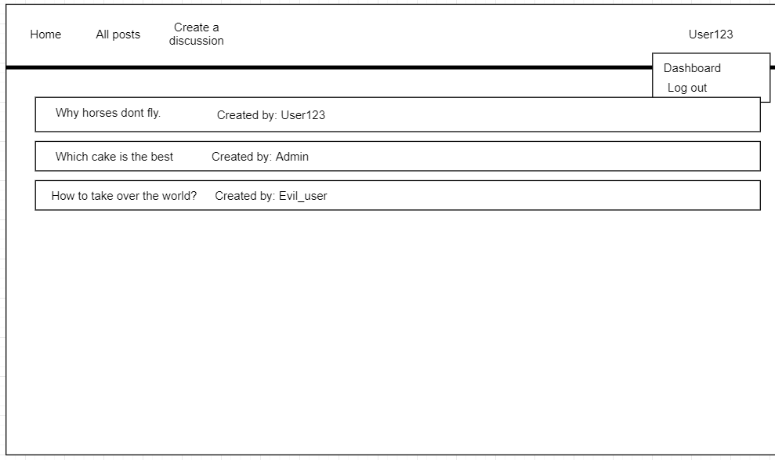

[Created with draw.io desktop application]